A guide for remote interviewing in workplace investigations.
By Gary Rogers, Head of investigation and audit services
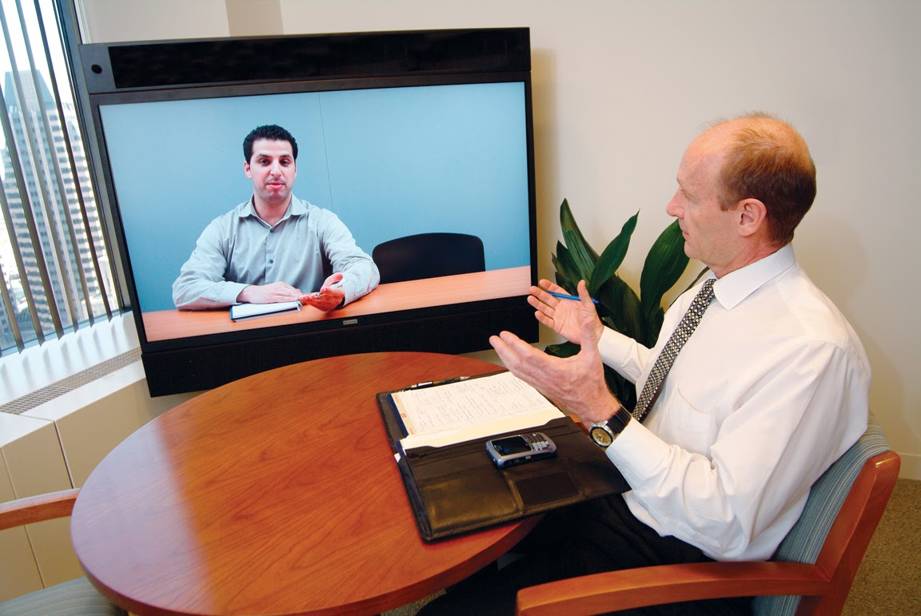
It has always been traditional to conduct witness interviews face-to-face, with numerous research and publications detailing the benefits, from body language and facial expressions to scripted and rehearsed answers, enabling the professional investigator to draw experienced conclusions to the integrity of evidence being provided.
However, in today’s modern age of technology, the diverse and geographically spread locations of workforces, flexible working legislation and shift working, the need for a more innovative approach to interviews is needed.
Telephone interviews have long been adopted in recruitment campaigns to great success, and virtual meetings are becoming more popular and advanced, so why not witness interviews?
Virtual platforms, such as Skype, Zoom, Microsoft Teams and many others, offer the professional investigator a means to conduct interviews using a platform that still enables face-to-face contact, despite being some distance from each other geographically.
The TCM Group has used this type of interview method in several investigations, and this paper provides some of its learning in conducting remote interviews.

The benefits
As previously mentioned, workforces are more flexible in working hours and locations, enabling a more diverse workforce, and the traditional workplace is no longer a 9 to 5, office-based role, but more a flexible and agile arena.
This poses investigators with the difficulty of organising interviews in line with varied work patterns and locations, and thus potentially prolonging the duration of an investigation.
Remote interviewing allows investigators to plan interviews around the witness and thereby removing extended delays and travelling.
It also provides the witness the opportunity to conduct the interview in a safe place, comfortable and familiar and provides a sense of control. This enables the investigator to build the important rapport and trust of a witness more easily and quickly than, say, the time spent if the interview was conducted in the workplace or a strange, unfamiliar environment.
But, let us not forget that the investigator is also a flexible and agile worker, working varied hours and locations, and so remote interviewing also benefits the investigator.
It provides the investigator, and the witness, the opportunity to feel at ease and comfortable, thus creating a more friendly and trusted interaction.
The challenges
Finding the right platform is paramount, as the investigator will need it to be stable, free from intermittent breakdown (i.e. loss of connection, freezing, etc) to maintain the momentum, and also it will need to be a safe and secure platform, given the confidentiality of the interview.
A solid, well-respected and trusted platform should be used and secure safeguards in place, such as encryption (particularly when recording and only with the witness’s agreement) and an approved cyber security certification.
The investigator should also consider that not everyone is comfortable around technology and its use, and so it may be that a telephone interview is more appropriate.
The remote interview
Having outlined the benefits and challenges, it is important that the professional investigator adapts their interview techniques and skills to each medium used.
When conducting telephone interviews, for example, you cannot see facial expressions or body movements, so it’s important to adopt a more listening skills approach.
Long pauses, silences, background noises or voices and hesitation or the ‘Err, Umm’ responses are key indicators for investigators.
For virtual interviews, the visual skills of a professional investigator still play an important role, but these also need to be used in conjunction with the listening skills need for telephone interviews.
Why?
Virtual interviews provide visibility of the witness, but there are aspects that are ‘out of shot’ and so it’s important that both skills are used in conjunction
When all said and done, in an ever-changing landscape, the necessity, benefits and effectiveness of remote interviewing are clearly demonstrable to the modern professional investigator.
External scrutiny and Employment Tribunal
If there is any reluctance in using remote interviewing in workplace investigations, it is likely to stem from the risk of external scrutiny or at an Employment Tribunal.
In my 32 years of investigation experience, I have used telephone and virtual interview techniques and, at disciplinary, appeal and Employment Tribunal hearings, they have never been subject to question or validity.
What should be consistent in any investigation is that it is conducted fairly, thoroughly and be reasonable. The technique used in an interview is not the issue, it is the process that has been followed in the investigation, that all evidence is captured, appropriate witnesses interviewed, and notes agreed, and that the outcome is fair and reasonable.
The professional investigator will always follow these core principles, no matter what techniques are used for interviewing witnesses, and maintain their subjectivity and professionalism in any investigation.
TCM are here to help you to get your investigations right first time
Since 2001, we have been delivering investigations into complex workplace issues within organisations across the world. These range from grievances and complaints to allegations of bullying, harassment, discrimination, misconduct and fraud. We have a team of the top investigators in the UK and we work on a retained basis or a ‘call off’ basis with numerous organisations.
We also deliver 3 levels of investigations skills training, all of which are accredited with The CPD Certification Service:
- Core investigation skills – one day.
- Practical investigation skills – two days.
- Advanced investigation skills – three days.
TCM also deliver bullying, incivility and conflict audits. These can be undertaken within teams, across departments or across the entire organisation. Our audits examine several areas including:

- Culture.
- Leadership and management behaviour and practices.
- Policies, processes and procedures.
- Employee and patient experience
- Wellbeing and engagement
- Inclusion.

For more details about any of our investigation, training or audit services, please contact me on 020 7092 3181 or by email gary.rogers@thetcmgroup.com. Thank you!

